

SCAD COLLEGE OF ENGINEERING AND TECHNOLOGY,Cheranmahadevi, Tirunelveli

Final Year Project On
Inventory Management System for Retailers

Submitted By
Ilakkiya K (952819104701)
Leethiyal D (952819104302)
Madhumitha S(952819104025)
Gokila R(952819104012)
TEAM ID :PNT2022TMID50585
In partial fulfillment of the requirement for the degree of

Bachelor of Engineering

(Computer Science and Engineering)

Under the Supervision of
Mr. Ram Prasath
Mr. Esakkimuthu

Faculty of Computer Science Department

RECOMMENDATION

This is to certify that the Professional Readiness For Innovation, Employability and Entrepreneurship Project on Inventory Management System for Retailers

Submitted By

TEAM ID :PNT2022TMID50585

Entitled
“INVENTORY MANAGEMENT SYSTEM FOR RETAILERS”

Has been prepared and approved by this college.
This report is forwarded for examination to SCAD College of Engineering and Technology

DECLARATION

We hereby declare that the work reported in this project work on “Inventory Management System for Retailers” submitted to SCAD College of Engineering and Technology is our original work done in the form of partial requirement for the degree of Bachelor of Engineering in Computer science under the mentor of Mr. Ram Prasath, and Evaluator for the project Mr. Esakkimuthu. The material contained in the report has not been submitted to any University or Institution for the award of any degree.

ACKNOWLEDGEMENT

This project is prepared in the partial fulfillment of the requirement for the degree of Bachelor of Engineering in Computer Science. The satisfaction and success of completion of this task would be incomplete without heartfelt thanks to people whose constant guidance, support and encouragement made this work successful. On doing this undergraduate project we have been fortunate to have help, support and encouragement from many people we would like to acknowledge them for their cooperation.
Our first thanks goes to Anna University for designing such a worthy syllabus and making us do this project. Our next batch of thanks goes to the faculty of our Department of SCAD College of Engineeirng and Technology without whose help our project would have been impossible. This list includes Mr. Ram Prasath. Our very sincere and heartfelt thanks go to Mr. Esakkimuthu our project supervisors who constantly guided us through the project time period. Without his guidance, our project would have been impossible. Last but not the least we want to thank every direct and indirect hands that were involved in completion of this project.
Finally, our heartfelt thanks goes to Mr. Vasudeva Hanush, Industrial Mentor of IBM as an external examiner for our project and thanks for sharing his valuable time with us to evaluate our work and provide professional suggestion with us.
This project has been a wonderful experience where we have learnt and experienced many beneficial things.

With Regards,
Ilakkiya K (952819104701)
Leethiyal D (952819104302)
Madhumitha S(952819104025)
Gokila R(952819104012)

ABSTRACT

This project is aimed at developing a desktop based application named Inventory Management System for Retailers to managing the inventory system of any organization. The Inventory Management System for Retailers refers to the system and processes to manage the stock of organization with the involvement of Technology system. This system can be used to store the details of the inventory, stock maintenance, update the inventory based on the sales details, generate sales and inventory report daily or weekly based. This project is categorize individual aspects for the sales and inventory management system. In this system we are solving different problem affecting to direct sales management and purchase management. Inventory Management System for Retailers is important to ensure quality control in businesses that handle transactions resolving around consumer goods. Without proper inventory control, a large retail store may run out of stock on an important item. A good inventory management system will alert the wholesaler when it is time to record. Inventory Management System For Retailers is also on important means of automatically tracking large shipment. An automated Inventory Management System for Retailers helps to minimize the errors while recording the stock.

Table of Contents

1. INTRODUCTION
1.1 Project Overview
1.2 Purpose
2. LITERATURE SURVEY
2.1 Existing problem
2.2 References
2.3 Problem Statement Definition
3. IDEATION & PROPOSED SOLUTION
3.1 Empathy Map Canvas
3.2 Ideation & Brainstorming
3.3 Proposed Solution
3.4 Problem Solution fit
4. REQUIREMENT ANALYSIS
4.1 Functional requirement
4.2 Non-Functional requirements
5. PROJECT DESIGN
5.1 Data Flow Diagrams
5.2 Solution & Technical Architecture
5.3 User Stories
6. PROJECT PLANNING & SCHEDULING
6.1 Sprint Planning & Estimation
6.2 Sprint Delivery Schedule
7. FEATURE
8. TESTING
8.1 User Acceptance Testing
9. RESULTS
- ADVANTAGES & DISADVANTAGES
11. CONCLUSION
12. FUTURE SCOPE
13. SOURCE CODE
GitHub Link

INTRODUCTION

Project Overview
The project Inventory Management System is a complete desktop based application designed on .Net technology using Visual Studio Software. The main aim of the project is to develop Inventory Management System Model software in which all the information regarding the stock of the organization will be presented. It is an intranet based desktop application which has admin component to manage the inventory and maintenance of the inventory system.
This desktop application is based on the management of stock of an organization. The application contains general organization profile, sales details, Purchase details and the remaining stock that are presented in the organization. There is a provision of updating the inventory also. This application also provides the remaining balance of the stock as well as the details of the balance of transaction.
Each new stock is created and entitled with the named and the entry date of that stock and it can also be update any time when required as per the transaction or the sales is returned in case. Here the login page is created in order to protect the management of the stock of organization in order to prevent it from the threads and misuse of the inventory.

Purpose
Products are considered as the business resources for the organization. This includes managing the product with appropriate way to review any time as per the requirement. Therefore it is important to have a computer based IMS which has the ability to generate reports, maintain the balance of the stock, details about the purchase and sales in the organization. Before developing this application we came up with 2 Inventory Management System existing in the market, which helps to give the knowledge for the development of our project. These application software are only used by the large organization but so we came up with the application which can be used by the small company for the management of their stock in the production houses.
After analyzing the other inventory management system we decided to include some of common and key features that should be included in every inventory management system. So we decided to include those things that help the small organization in a way or other.

Literature Survey
After analyzing many existing IMS we have now the obvious vision of the project to be developed. Before we started to build the application team had many challenges. We defined our problem statement as:
- To make desktop based application of IMSR for small organization.
- To make the system easily managed and can be secured.
- To cover all the areas of IMSR like purchase details, sales details and stock management.
- To fulfill the requirement for achieving the Bachelor’s degree of Computer
Information System.
- To know the fundamentals of the .Net Technology and Visual Studio with the Net Framework.
  - Existing Problem
Monitor and Categorize Products: Production monitoring gives you a complete picture of the manufacturing process, alerts you to any faults early on, and helps you avoid delivery delays. And when you understand and control your production process from beginning to end, only two things can happen higher product quality and happier consumers.
Manage Product Pricing: Managing Product Price is a set of tools, procedures, methods, and cultures used by companies that create and manufacture products to ensure that their profit (or cost) targets are met.
Manage Reservation and Orders: They must manage reservations and maintain correct records to ensure that all rooms are filled as soon as feasible. This job frequently collaborates with the managers of the revenue and rooms divisions.
Revenue and Expenses Management: Revenue and management aid in the prediction of consumer demand in order to maximize revenue growth by optimizing inventory and price availability. The goal of revenue management isn’t to sell a product for a cheap price today in order to offer it for a greater price tomorrow.
  - References
Software Reference
➢ Swatik Accounting And Inventory Software
High-tech Software, Kalimati
Inventory Management Software Sagar International, Balkhu
Website
Visual Studio Official Site: https://msdn.microsoft.com/en-us/library/dd492171
2.3 Problem Statement Definition
Problem Statement: Demand is frequently unpredictable in inventory systems, and lead times can often vary. Managers frequently keep a safety supply to minimize shortages. In such cases, it’s difficult to say what order amounts and reorder points will result in the lowest total inventory cost.
The inventory issue refers to the general issue of deciding how much inventory to keep on hand in expectation of possible demand. Loss occurs when a business is unable to meet demand (for example, when a store loses sales or when soldiers in a war run out of ammunition) or when commodities are stocked for which there is no demand.
Solution: Inventory management’s major goal is to make ordering, stocking, storing, and using inventory as simple and efficient as possible for firms. You’ll always know what things are in stock, how many there are, and where they are if you manage your inventory properly. An inventory system’s main function is to keep track of your products and supplies. When you buy inventory, you need to keep track of when you bought it, when you sold it, and how much you have on hand. It also tells you where your inventory is.
- Ideation & Proposed Solution
  - Empathy map canvas
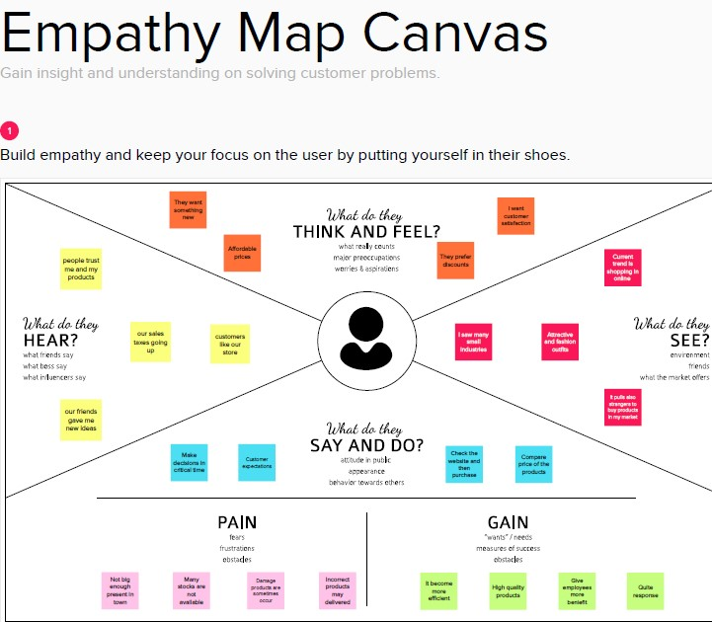
  - Ideation brainstorming
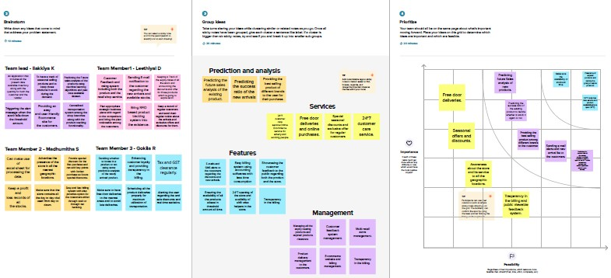
  - Proposed solution
1· The customers are not satisfied with the retailers store since it doesn’t have enough supplements and the deliveries were not made on time
2. Idea / Solution description
The product availability is tracked daily and an alert system in again kept on to indicate those products which falls below the threshold limit.
· All the customers can register their accounts after which they will be given a login credentials which they can use whenever they feel like buying the stocks.
. The application allows the customers to know all the present time available stocks and also when the new stock will be available on the store for them to buy
3. Novelty / Uniqueness
· Prediction of the best selling brand of all certain products based on their popularity, price and customer trust and satisfaction will be implemented.
4. Social Impact / Customer Satisfaction
· The customer satisfaction will be improved for getting appropriate response from the retailers and that too immediately.
5. Business Model (Revenue Model) ML algorithms for all the prediction purposes using all the past dataset since datasets are undoubtedly available in huge amounts. Can deploy the most appropriate business advertising models
  - Problem solution fit
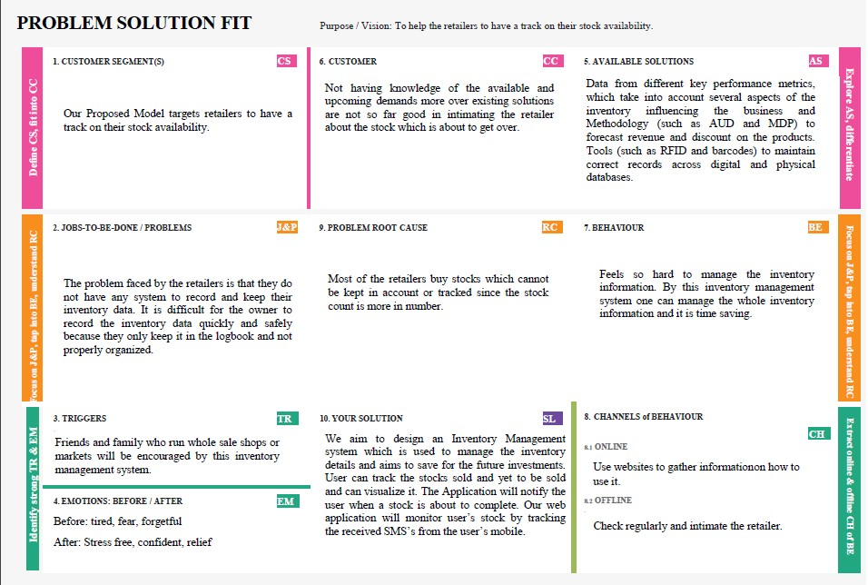

- Requirement Analysis
4.1. Functional Requirements
The goal for the application is to manage the inventory management function of the organization. Once it is automated all the functions can be effectively managed and the organization can achieve the competitive advantage. Business requirement are discussed in the Scope section, with the following additional details:
➢ 1.Helps to search the specific product and remaining stock.
➢ 2.Details information about the product sales and purchase.
➢ 3.Brief Information of the organization today’s status in terms of news, number of present inventory as per the date entered.
➢ 4.It helps to identify the total presented inventory in the company
4.2. Non-Functional Requirements➢
1. Able to edit the entry as per entry.
➢ 2.Able to add, modify and delete the stock entry.
➢3. Able to check the stock available.
➢4. Able to check the balance payment.
➢ 5.Able to view the remaining sales stock.

- Project Design
  - Data flow Diagram
Process Flow Diagram or Flowchart is a diagram which uses geometric symbols and arrows to define the relationships. It is a diagrammatic representation of the algorithm. The Process flow Diagram of our application is shown below:
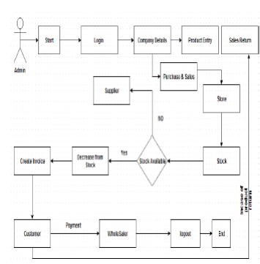

  - Solution and Technical Architecture
The visual part is implemented using all kinds of swing components, which does not make database calls. The main function of this tier is to display information to the user upon user’s request generated by user’s inputs such as firing button events. For example, inventory list will display when user click “display” button if he or she wants to know the list of stock remaining in the organization.
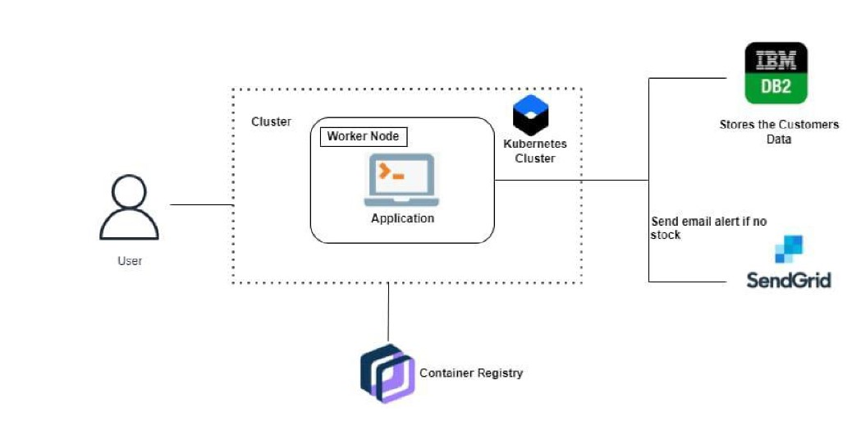
  - User Stories
It is important to keep customers happy with what they’re getting. As the number of companies grows, the competition gets more fierce as well, making an inventory management software solution one of the best assets to have in a retail business.
What this does is it lessens the time and effort spent on menial tasks that eat up a substantial amount of time. In growing businesses, time is part of the investment. Once too much time has been taken by a company to ship items or take in orders, customers quickly lose interest. When customers lose interest, they transfer to people who can give them high-quality items in the shortest time possible.
Inventory management software is one of the best methods to use in ensuring customer satisfaction and loyalty to your business. It helps by implementing core features and functionalities such as basic inventory control, barcoding and scanning, demand forecasting, accounting and lot tracking. These features are designed to keep track of your inventory and avoid running out of stock.
- Project Planning and Scheduling
  - Sprint planning & Estimation
Reordering of Inventory:
Inventory reaches a specific threshold; our Inventory Management System can be programmed to tell managers to reorder that product. This helps companies avoid running out of products or tying up too much capital in inventory. This is a very good feature and adds extra advantages to our system. Due to less involvement of human chances of error has been reduced exponentially.

Asset Tracking:
Inventory is a current asset for any company so tracking the asset is mandatory. When an item is in a warehouse, it can be tracked via its barcode or some other ways like serial number, lot number, or revision number. This will help the user and company to track his net worth very clearly. This makes the calculation of net profit and loss more quickly than previous.

Email notification:
Whenever customer books any order in our company an email alert has been sent to him/her as confirmation and tracking id and email notification of their order status send to them periodically.

Service Management:
Companies that are basically service-oriented rather than product-oriented can use an inventory management system to track the cost of the materials they use to deliver facilities, such as cleaning supplies. This way, they can attribute prices to their services that reflect the total cost of executing them.

Barcode:
Due to the use of the barcode process of tracking the product becomes easier. Barcodes are often the means whereby data on products and orders are entered into the inventory management system. A barcode reader is used to read barcodes and look up info on the products they represent. Radio-frequency identification (RFID) tags and wireless methods of product identification are also growing in fame.
  - Sprint Delivery Schedule
- Literature Survey & Information Gathered on28 September
Literature survey on selected project and gathered information by referring the project’s related technical papers, research publications, etc.
2.Prepared Empathy Map on 24 September
Prepared empathy map canvas to capture the user’s pains & gains and prepare the list of problem statements.
3.Ideation on 25 September
To list by the organizing brainstorm sessions and prioritize the top three ideas based on the feasibility and importance.
4.Proposed Solution on 23 September
To prepare the proposed solution documents, which includes the novelty, feasibility of ideas, business model, social impact, scalability of the solution, etc.
5.Problem Solution Fit on 30 September
Prepared the problem solution fit document.
- Feature
An easy-to-use interface that doesn’t require advanced training, support or documentation. Automation for eliminating manual processes of business functions related to inventory management. A reliable, secure database that provides accurate, real-time data. Performance that enables fast, actionable inventory monitoring and control. The ability for administrators to easily add software modules with minimal configuration so that the system is scalable. Software integrations and automated features that minimize manual inventory updates or inputs.

- Testing
The purpose of software testing is to access or evaluate the capabilities or attributes of a software program’s ability to adequately meet the applicable standards and application need. Testing does not ensure quality and the purpose of testing is not to find bugs. Testing can be verification and validation or reliability estimation. The primary objective if testing includes:
➢ To identifying defects in the application.
➢ The most important role of testing is simply to provide information.
➢ To check the proper working of the application while inserting updating and deleting the entry of the products
  - User- Acceptance Testing
This type of testing is the testing of individual software components. It is typically done by the customers and not by the testers. It requires details information and knowledge about the internal program design and code to perform this.
During this testing, we carried out various testing task such as the reflection of the unit data on database and its interface. Various types of bugs associated with the component were identified and fixed. We use various functional keys to test our software.
In our software unit testing is concerned with the stock units, opening stock units and product units validation as well as the validation of product units.
- Results
Since this is our first project it has some limitation. Due to less knowledge in particular fields and limited time we were not able to fulfill all our expectations that we expected we could do while the project got started. We hope this limitations are considerable. Some of the project limitations are:
➢ This application is not suitable for those organization where there is large quantity of product and different level of warehouses. This software application is able to generate only simple reports. Single admin panel is only made. It is not suitable for large organization.
Doing something for long time periods always gives good lesson. Some of the things that our team learnt are listed as below:
➢1. Basically we learnt to work in team.
➢2. Learnt about the IMS process.
➢3. Learnt about .NET technology, its components and ways to implement them
➢4. Learnt to work in pressure and to be patient.
➢ 5.Learnt to manage the database under Microsoft SQL server 2008.
- Advantages and Disadvantages
It is important to keep customers happy with what they’re getting. As the number of companies grows, the competition gets more fierce as well, making an inventory management software solution one of the best assets to have in a retail business.
What this does is it lessens the time and effort spent on menial tasks that eat up a substantial amount of time. In growing businesses, time is part of the investment. Once too much time has been taken by a company to ship items or take in orders, customers quickly lose interest. When customers lose interest, they transfer to people who can give them high-quality items in the shortest time possible.
Inventory management software is one of the best methods to use in ensuring customer satisfaction and loyalty to your business. It helps by implementing core features and functionalities such as basic inventory control, barcoding and scanning, demand forecasting, accounting and lot tracking. These features are designed to keep track of your inventory and avoid running out of stock.
Other benefits you can gain from inventory management software include the ability to process and follow work orders directly in the system, create product variations, identify pieces of inventory through serial numbers, bundle individual items to sell as a package, create special orders to meet individual customer needs, as well as track inventory levels across multiple locations.
Inventory management software solutions have features that seek to improve the overall productivity of your business. To achieve maximum customer satisfaction, retail stores and small organizations must apply the most up-to-date technology to assist in daily tasks while also optimizing for the important ones. Even though these tasks might seem like a chore, they help to keep the business running and, more importantly, growing.
- Conclusion
To conclude, Inventory Management System is a simple desktop based application basically suitable for small organization. It has every basic items which are used for the small organization. Our team is successful in making the application where we can update, insert and delete the item as per the requirement. This application also provides a simple report on daily basis to know the daily sales and purchase details. This application matches for small organization where there small limited if godwoms. Through it has some limitations, our team strongly believes that the implementation of this system will surely benefit the organization.
- Future Scope
Since this project was started with very little knowledge about the Inventory Management System, we came to know about the enhancement capability during the process of building it. Some of the scope we can increase for the betterment and effectiveness oar listed below:
➢1. Interactive user interface design.
➢ 2.Manage Stock Godown wise.
➢ 3.Use of Oracle as its database.
➢ 4.Online payment system can be added.
➢ 5.Making the system flexible in any type.
➢ 6.Sales and purchase return system will be added in order to make return of
products.
➢7. Lost and breakage
- Source code
Mainpage.html:
<!DOCTYPE html>
<html>
<head>
<h1> INVENTORY MANAGEMENT SYSTEM FOR RETAILERS</h1>
<body>
<a href="about.html"><button >home</button></a>
<a href="home2.html"><button >about</button></a>
<a href="signin.html"><button >signin</button></a>
<a href="signup.html"><button >signup</button></a>

</body>
<html>

<style>
h1{
font-size: 50px;
font-family: 'Gill Sans', 'Gill Sans MT', Calibri, 'Trebuchet MS', sans-serif;
font-style: italic;
}

body{
background-image: url(https://img.freepik.com/free-photo/black-friday-elements-assortment_23-2149074075.jpg?w=2000);
background-position: center;
background-size: cover;

}
ul{
text-align: left;
text-decoration-color: black;
font-size: 135%;
}
input{
width: 1000px;
margin: 50px 20px;
height: 50px;
border: #020202;
border-radius: 10px;
}
</style>
<head>
<title>Retailer</title>
<link rel="stylesheet" href="">
</head>
<body>

<input type="text" placeholder="Search Item">
<ul id="myMenu">
<li><a href="#">Women's wear</a></li>
<li><a href="#">Men's wear</a></li>
<li><a href="#">Kid's wear</a></li>
<li><a href="#">Cosmetic Item</a></li>
<li><a href="#">Jewelleries</a></li>
<li><a href="#">Electronic Gadgets</a></li>
<li><a href="#">Home appliances</a></li>
<li><a href="#">Stationary</a></li>

</ul>

</body>
</html>
</body>
</html>
Main page:
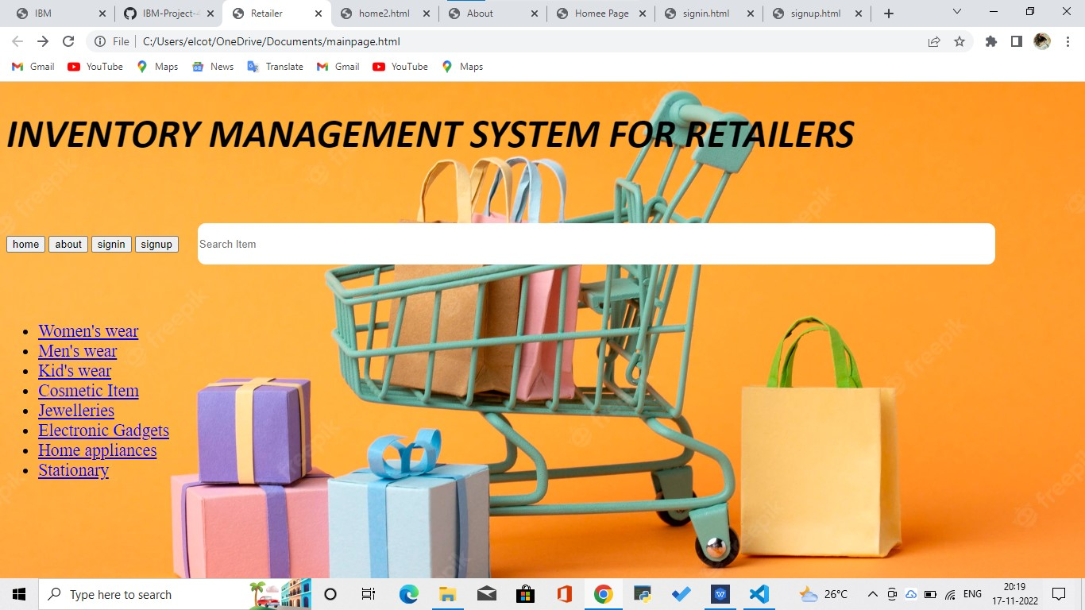
About.html:
<!DOCTYPE html>
<html lang="en">
<head>
<meta charset="UTF-8">
<meta http-equiv="X-UA-Compatible" content="IE=edge">
<meta name="viewport" content="width=device-width, initial-scale=1.0">
<link rel="stylesheet" href="https://cdn.jsdelivr.net/npm/bootstrap@4.6.1/dist/css/bootstrap.min.css">
<script src="https://cdn.jsdelivr.net/npm/jquery@3.6.0/dist/jquery.slim.min.js"></script>
<script src="https://cdn.jsdelivr.net/npm/popper.js@1.16.1/dist/umd/popper.min.js"></script>
<script src="https://cdn.jsdelivr.net/npm/bootstrap@4.6.1/dist/js/bootstrap.bundle.min.js"></script>
<title>About</title>
<style>
*{
margin:0px;
box-sizing: border-box;
}
body{
font-family: Arial, Helvetica, sans-serif;
margin: 0;
background: #8e9eab; /* fallback for old browsers */
background: -webkit-linear-gradient(to right, #eef2f3, #8e9eab); /* Chrome 10-25, Safari 5.1-6 */
background: linear-gradient(to right, #eef2f3, #8e9eab); /* W3C, IE 10+/ Edge, Firefox 16+, Chrome 26+, Opera 12+, Safari 7+ */

}
#about{
margin-top: 50px;
}
h1{
font-size: 60px;
}
p{
font-size: 20px;
}
#cards{
padding: 30px
}
.column{
padding: 30px;
}
.card{
border: none;
box-shadow: rgba(0, 0, 0, 0.24) 0px 3px 8px;
}
button{
margin-left: 100px;
margin-top: 50px;
}
#home-btn{
margin-top: 50px;
margin-left: 100px;
padding:10px 30px;
font-size: 30px;
}
</style>
</head>
<body>

<a href="mainpage.html" class="btn btn-dark stretched-link" id="home-btn">Home</a>
<div class="container-fluid" id="about">
<h1>ABOUT US </h1>
<p>Who are we and what we do.</p>

</div>

<h2 style="text-align:center">Our Team</h2>
<div class="container-fluid" id="cards">
<div class="row">
<div class="column">
<div class="card" style="width:400px;">
<img src="girl.jpg" alt="Card image" style="width:100%"/>

<div class="card-body">
<h4 class="card-title">ILAKKIYA</h4>
<h5 class="title">Team Leader</h5><br>
<p class="card-text">CSE Engineer<br>Assigns tasks to members and manages the server.<br></p><br>
<p>ilakkiya1402@gmail.com</p><br>
<a href="#" class="btn btn-primary stretched-link">See Profile</a>
</div>
</div>
</div>
<div class="column">
<div class="card" style="width:400px">
<img src="girl.jpg" alt="Card image" style="width:100%"/>
<div class="card-body">
<h4 class="card-title">LEETHIYAL</h4>
<h5 class="title">Team Member 1</h5><br>
<p class="card-text">CSE</p> Engineer<br>Does front end tasks.<br></p><br>
<p>leethiyaldevaraj67@gmail.com</p><br>
<a href="#" class="btn btn-primary stretched-link">See Profile</a>
</div>
</div>
</div>

<div class="column">
<div class="card" style="width:400px">
<img src="girl.jpg" alt="Card image" style="width:100%">
<div class="card-body">
<h4 class="card-title">MADHUMITHA</h4>
<h5 class="title">Team Member 2</h5><br>
<p class="card-text">CSE Engineer.<br>Does back end tasks.<br></p><br>
<p>madhusugu2001@gmail.com</p><br>
<a href="#" class="btn btn-primary stretched-link">See Profile</a>
</div>
</div>
</div>

<div class="column">
<div class="card" style="width:400px">
<img src="girl.jpg" alt="Card image" style="width:100%">
<div class="card-body">
<h4 class="card-title">GOKILA</h4>
<h5 class="title">Team Member 3</h5><br>
<p class="card-text">CSE Engineer.<br>Manages storage and data.</p><br>
<p>gokilar@gmail.com</p><br>
<a href="#" class="btn btn-primary stretched-link">See Profile</a>
</div>
</div>
</div>

</div>
</body>
</html>
About page:
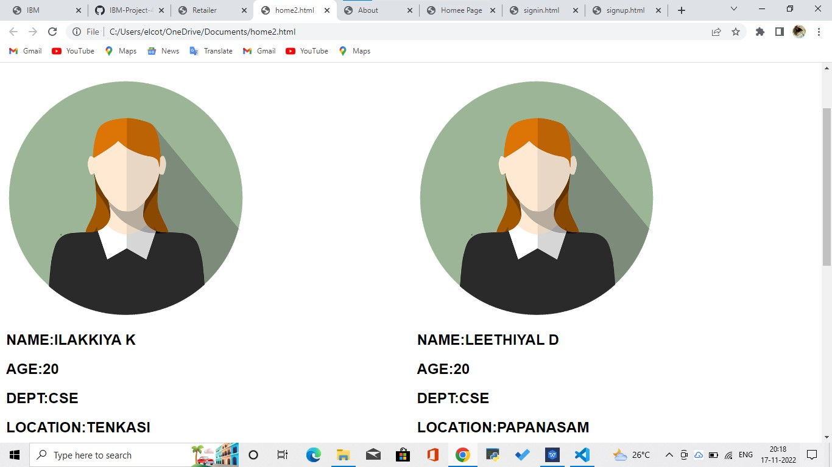
SignIn/Up Page:
SignIn.html:
<!DOCTYPE html>
<html>
<head>
<meta name="viewport" content="width=device-width, initial-scale=1">
<link rel="stylesheet" href="https://cdn.jsdelivr.net/npm/bootstrap@4.6.1/dist/css/bootstrap.min.css">
<script src="https://cdn.jsdelivr.net/npm/jquery@3.6.0/dist/jquery.slim.min.js"></script>
<script src="https://cdn.jsdelivr.net/npm/popper.js@1.16.1/dist/umd/popper.min.js"></script>
<script src="https://cdn.jsdelivr.net/npm/bootstrap@4.6.1/dist/js/bootstrap.bundle.min.js"></script>
<style>
body {font-family: Arial, Helvetica, sans-serif;
background: #ccc; /* fallback for old browsers */
background: -webkit-linear-gradient(to right, #eef2f3, crimson); /* Chrome 10-25, Safari 5.1-6 */
background: linear-gradient(to right, #eef2f3, crimson ); /* W3C, IE 10+/ Edge, Firefox 16+, Chrome 26+, Opera 12+, Safari 7+ */}
form {
background-color: #eef2f3;
box-shadow: crimson;
border-radius: 10px;
}
h2{
text-align: center;
margin-top: 20px;
font-size: 40px;
font-weight: bolder;
}
input[type=text], input[type=password] {
width: 100%;
padding: 12px 20px;
margin: 8px 0;
display: inline-block;
border: 1px solid #ccc;
box-sizing: border-box;
border: none;
outline: none;
border-radius: 30px;
padding: 20px;
margin-bottom: 25px;
}
label{
font-size: 25px;
padding: 10px;
}
#signin {
padding: 10px 18px;

border: none;
cursor: pointer;
width: 50%;
border-radius: 20px;
margin-bottom: 20px;
}

a{
margin: 20px;
}

.container {
padding: 20px;
}

#form-box{
padding: 50px 200px;
}
.btns{
text-align: center;
}

</style>
</head>
<body>
<nav class="navbar navbar-expand-md bg-dark navbar-dark " >
<a class="navbar-brand" href="#">INVENTORY MANAGEMENT SYSTEM FOR RETAILERS</a>

<!-- Toggler/collapsibe Button -->
<button class="navbar-toggler" type="button" data-toggle="collapse" data-target="#collapsibleNavbar">
<span class="navbar-toggler-icon"></span>
</button>

<!-- Navbar links -->
<div class="collapse navbar-collapse" id="collapsibleNavbar">
<ul class="navbar-nav ">
<li class="nav-item">
<a class="nav-link" href="indexx.html">Home</a>
</li>
<li class="nav-item">
<a class="nav-link" href="about.html">About</a>
</li>
<li class="nav-item">
<a class="nav-link" href="signup.html">Sign In/Up</a>
</li>
</ul>

</div>
</nav>
<h2>Sign-in Form</h2>
<div class="container" id="form-box">
<form action="/action_page.php" method="post">

<div class="container">
<label for="uname"><b>Username</b></label>
<input type="text" placeholder="Enter Username" name="uname" required>

<label for="psw"><b>Password</b></label>
<input type="password" placeholder="Enter Password" name="psw" required>
<div class="btns">
<button class="btn btn-primary" id="signin" type="submit">Signin</button>
<p>Don't have an account?</p>
<a href="signup.html" id="signup" role="button">Signup</a>

</div>
</div>

</form>
</div>
</body>
</html>
SignIn/SignUp Page:
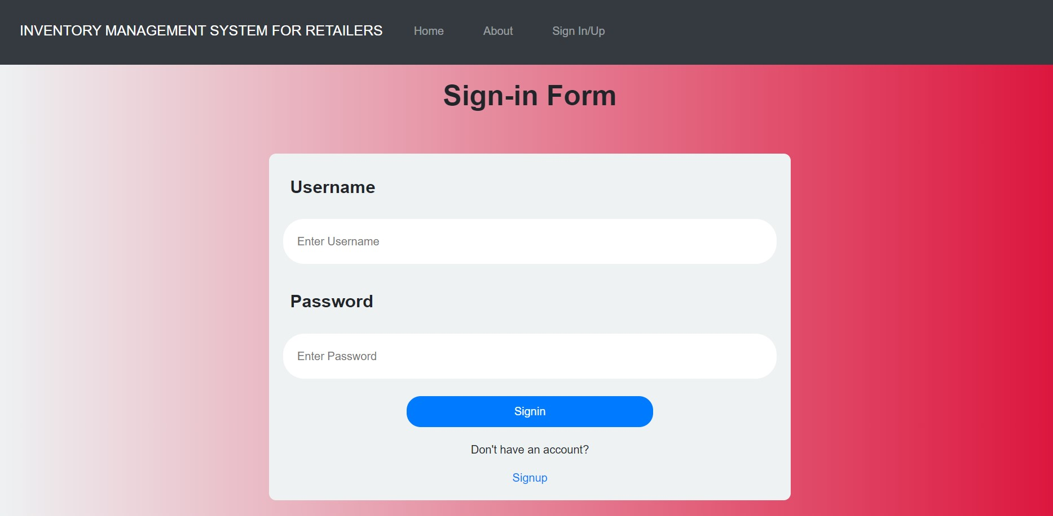
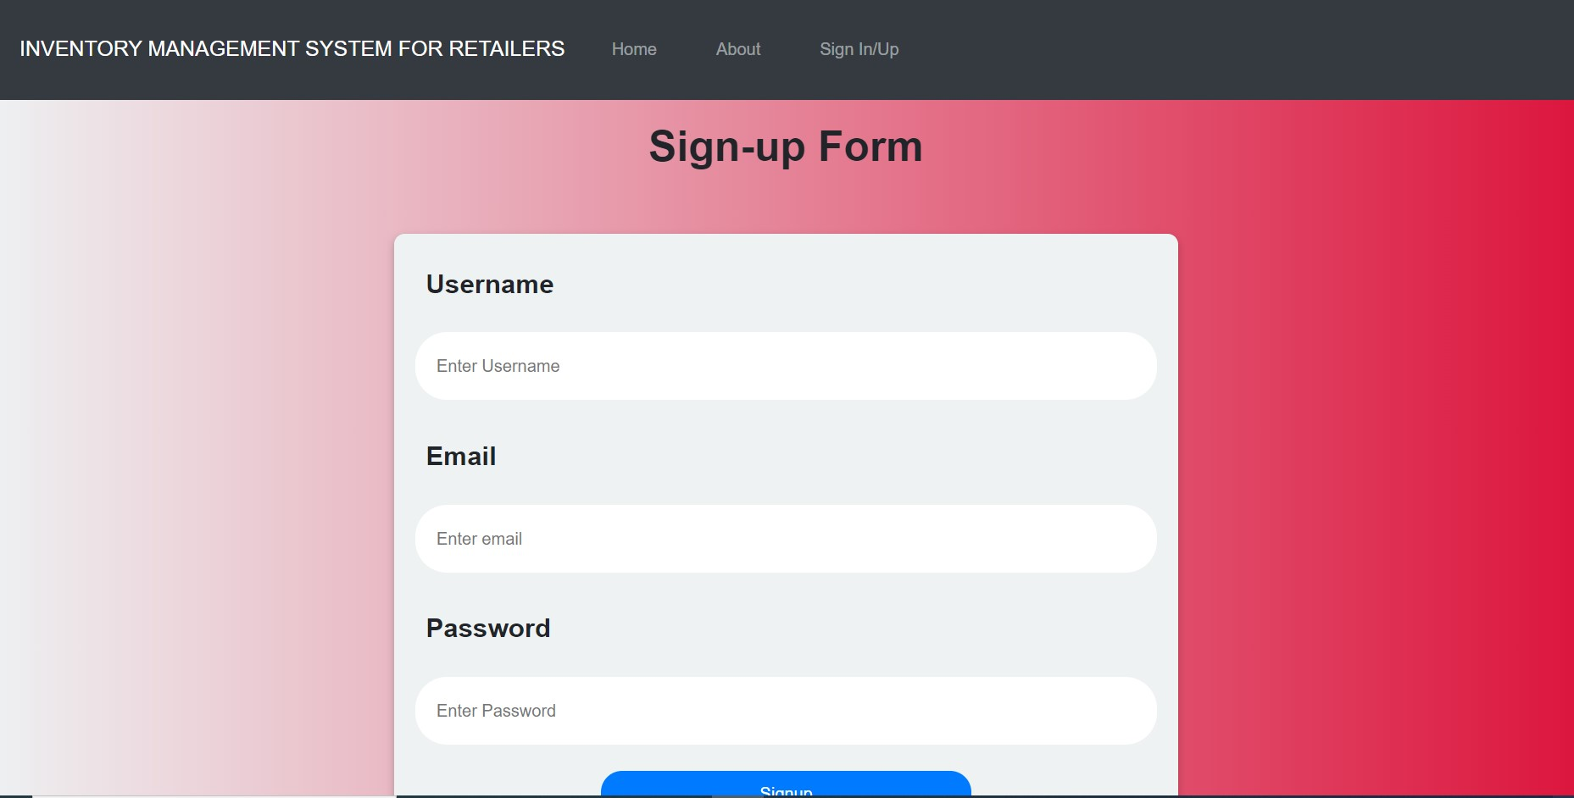

GitHub: https://github.com/IBM-EPBL/IBM-Project-47877-1660803028/

